EXPERIMENT 9
Simulation and Performance Evaluation of OFDMA Resource-Block Allocation for Multi-User Communication
Aim
To simulate an OFDMA system with multiple users and resource blocks in MATLAB, implement different resource-block allocation strategies, and compare throughput, resource utilization, and fairness.
Procedure
- Open MATLAB and create a new script named Exp9_OFDMA.m.
- Set the number of users to 4 and the number of resource blocks to 24.
- Set the resource-block bandwidth to 180 kHz and scheduling interval to 1 ms.
- Define traffic demands as [8 12 5 10] Mbit/s and average SNR values as [5 10 15 8] dB.
- Generate SNR values for each user and resource block.
- Calculate spectral efficiency using the Shannon capacity formula, limited to 6 bit/s/Hz.
- Implement round-robin, maximum-CQI, and traffic-aware allocation.
- Calculate the throughput of each user, total throughput, Jain’s fairness index, resource utilization, and unserved traffic.
- Run the program and compare the allocation maps and throughput graphs.
MATLAB PROGRAM:

clc;
clear;
close all;
rng(7);

K = 4;
NRB = 24;
BRB = 180e3;
Tslot = 1e-3;
etaMax = 6;

avgSNRdB = [5 10 15 8];
trafficMbps = [8 12 5 10];
demandBits = trafficMbps(:)*1e6*Tslot;

% Generate channel SNR
snrDB = avgSNRdB(:) + 4*randn(K,NRB);
snrLinear = 10.^(snrDB/10);

% Spectral efficiency and data per RB
eta = min(log2(1 + snrLinear),etaMax);
bitsPerRB = BRB*eta*Tslot;

names = {'Round Robin','Maximum CQI','Traffic Aware'};
A = zeros(K,NRB,3);

% 1. Round-robin allocation
for n = 1:NRB
u = mod(n-1,K)+1;
A(u,n,1) = 1;
end

% 2. Maximum-CQI allocation
for n = 1:NRB
[~,u] = max(snrDB(:,n));
A(u,n,2) = 1;
end

% 3. Traffic-aware allocation
served = zeros(K,1);
for n = 1:NRB
remaining = max(demandBits-served,0);
if all(remaining <= 0)
break;
end

metric = bitsPerRB(:,n).*(remaining./max(demandBits,eps));
metric(remaining <= 0) = -inf;
[~,u] = max(metric);

A(u,n,3) = 1;
served(u) = served(u) + min(bitsPerRB(u,n),remaining(u));
end

% Calculate performance
throughput = zeros(K,3);
fairness = zeros(1,3);
utilization = zeros(1,3);
rbCount = zeros(K,3);
unserved = zeros(K,3);

for s = 1:3
allocatedBits = sum(A(:,:,s).*bitsPerRB,2);
usefulBits = min(allocatedBits,demandBits);

throughput(:,s) = usefulBits/Tslot/1e6;
fairness(s) = sum(throughput(:,s))^2 / ...
(K*sum(throughput(:,s).^2)+eps);

rbCount(:,s) = sum(A(:,:,s),2);
utilization(s) = sum(A(:,:,s),'all')/NRB*100;
unserved(:,s) = max(trafficMbps(:)-throughput(:,s),0);
end

% Display results
for s = 1:3
fprintf('\n%s\n',names{s});
fprintf('User RBs Throughput Unserved\n');
for u = 1:K
fprintf('%d %2d %.3f %.3f\n', ...
u,rbCount(u,s),throughput(u,s),unserved(u,s));
end
fprintf('Total throughput = %.3f Mbit/s\n',sum(throughput(:,s)));
fprintf('Jain fairness = %.4f\n',fairness(s));
fprintf('RB utilization = %.2f %%\n',utilization(s));
end

% Allocation maps
figure;
for s = 1:3
subplot(3,1,s);
[u,rb] = find(A(:,:,s));
stem(rb,u,'filled');
grid on;
xlim([1 NRB]);
ylim([0.5 K+0.5]);
yticks(1:K);
xlabel('Resource Block');
ylabel('User');
title(names{s});
end

% Throughput comparison
figure;
bar(throughput);
xlabel('User');
ylabel('Throughput (Mbit/s)');
title('OFDMA Throughput Comparison');
legend(names,'Location','best');
grid on;

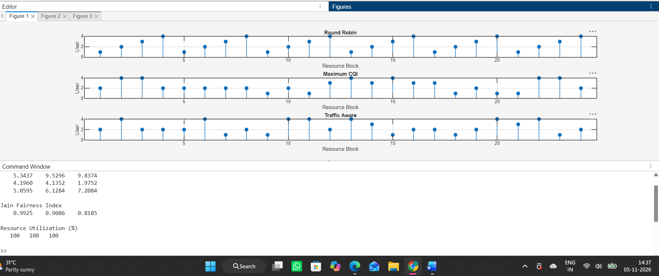

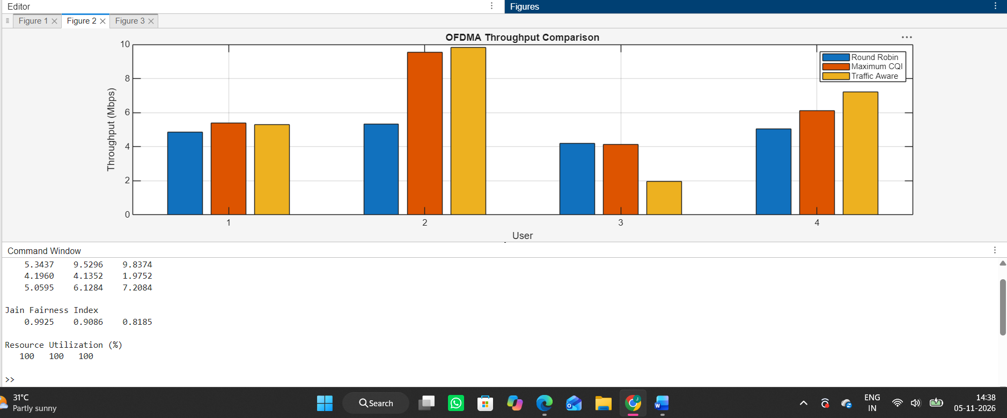

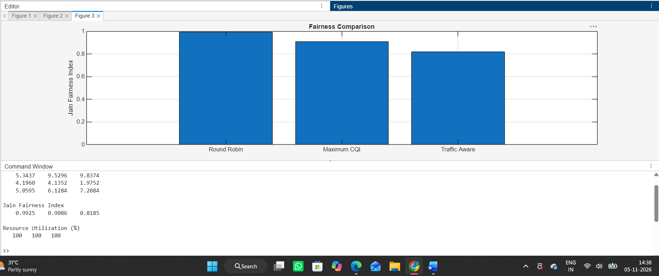

Result
The OFDMA system was simulated using round-robin, maximum-CQI, and traffic-aware resource-block allocation. User throughput, total throughput, fairness, resource utilization, unserved traffic, and allocation maps are displayed for comparison. Record the numerical results obtained from your MATLAB run.

